Speech to text code:

<head>  
  <meta charset="UTF-8">  
  <meta name="viewport" content=  
    "width=device-width, initial-scale=1.0">  
  
</head>  
  
<body>  
  <div class="words" contenteditable>  
    <p id="p"></p>  
  </div>  
  <div class="mb-5">  
<button id="start" class="btn btn-success mt-5 me-3">Start</button>  
<button id="pause" class="btn btn-warning mt-5 me-3">Pause</button>  
<button id="resume" class="btn btn-info mt-5 me-3">Resume</button>  
<button id="cancel" class="btn btn-danger mt-5 me-3">Cancel</button>  
</div>  
  
  <script>  
    var speech = true;  
    window.SpeechRecognition = window.SpeechRecognition  
            || window.webkitSpeechRecognition;  
  
    const recognition = new SpeechRecognition();  
    recognition.interimResults = true;  
    const words = document.querySelector('.words');  
    words.appendChild(p);  
        recognition.lang='ar';  
  
    recognition.addEventListener('result', e => {  
      const transcript = Array.from(e.results)  
        .map(result => result[0])  
        .map(result => result.transcript)  
        .join('')  
  
      document.getElementById("p").innerHTML = transcript;  
      console.log(transcript);  
    });  
  
    if (speech == true) {  
      recognition.start();  
      recognition.addEventListener('end', recognition.start);  
    }  
  </script>  
</body>  
  
</html>

**ESP32 Set up**

1. In your Arduino IDE, go to File> Preferences

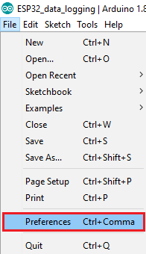

1. Enter the following into the “Additional Board Manager URLs” field:

<https://raw.githubusercontent.com/espressif/arduino-esp32/gh-pages/package_esp32_index.json>

Then, click the “OK” button:

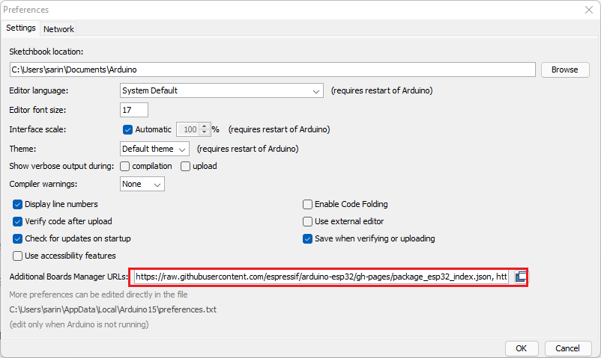

* 1. Open the Boards Manager.Go to Tools > Board > BoardsManager

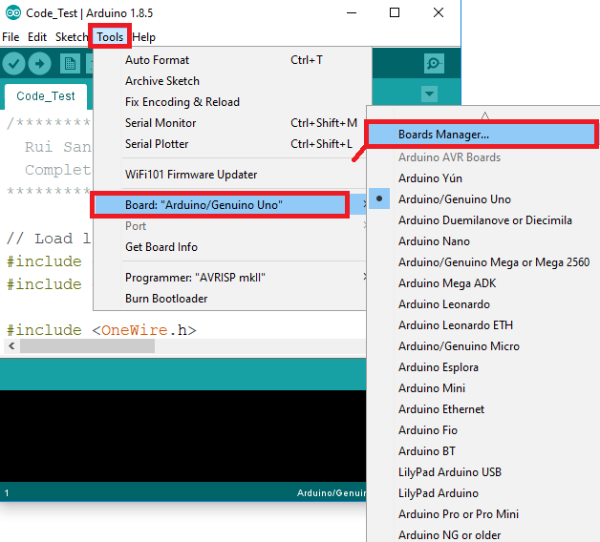

* 1. Search for ESP32 and press install button for the “ESP32byEspressifSystems“

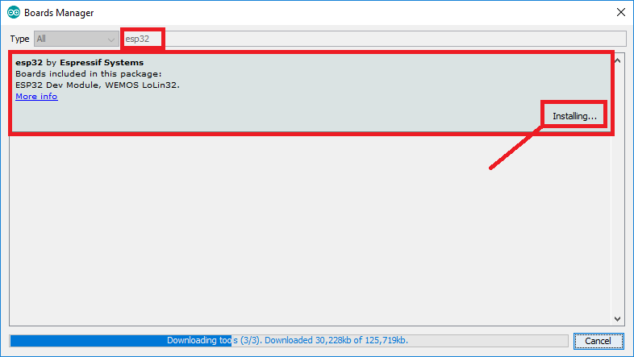

* 1. That’s it. It should be installed after a few seconds.

